1. Change your password to a password you would like to use for the remainder of the semester.

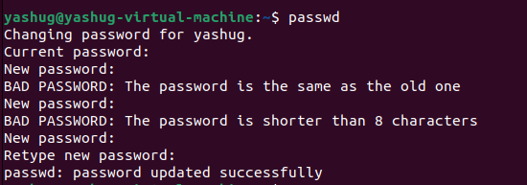

1. Display the system’s date.



1. Count the number of lines in the /etc/passwd file.



1. Find out who else is on the system.

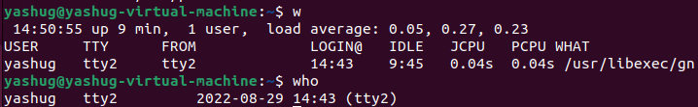

1. Direct the output of the man pages for the date command to a file named *mydate*.

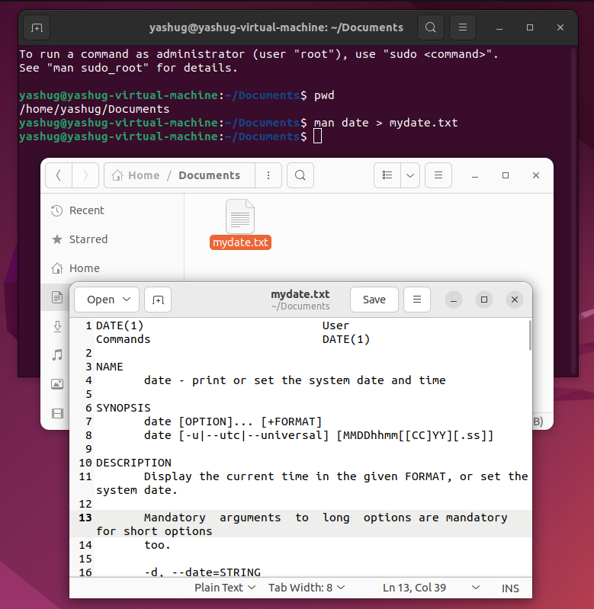

1. Create a subdirectory called *mydir*.

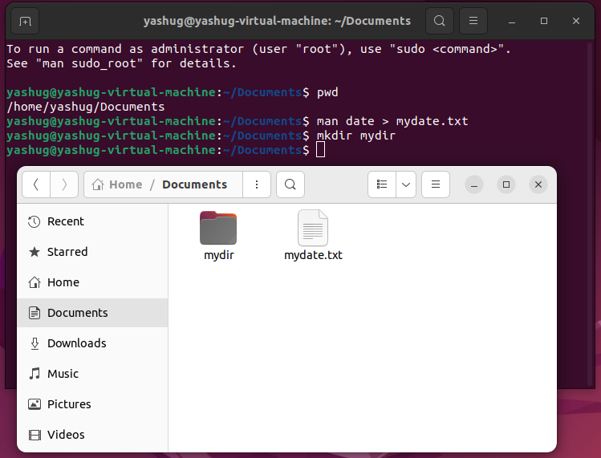

1. Move the file *mydate* into the new subdirectory.

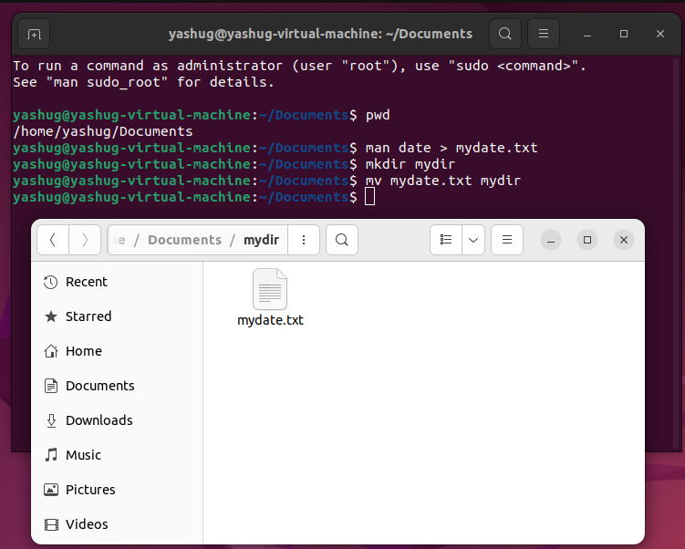

1. Go to the subdirectory *mydir* and copy the file *mydate* to a new file called *ourdate*

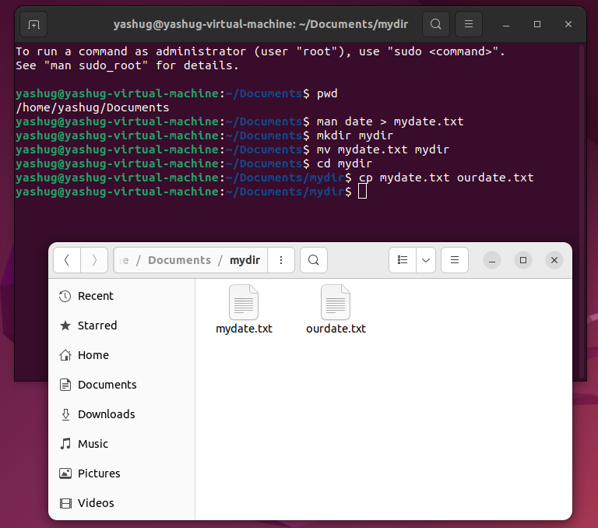

1. List the contents of *mydir*.

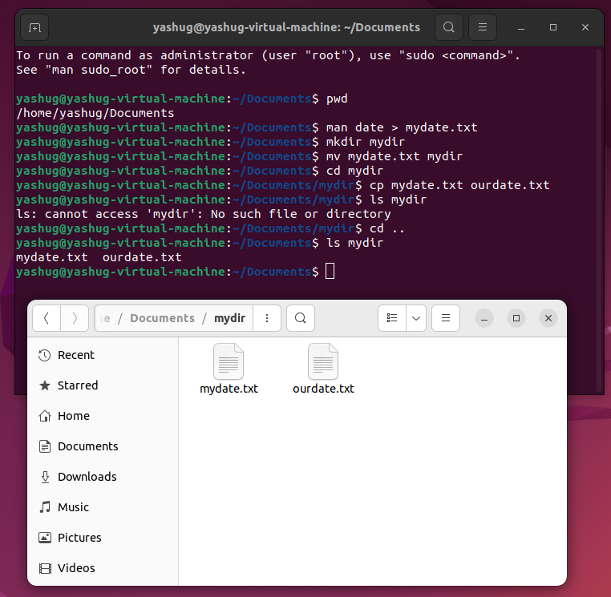

1. Do a long listing on the file *ourdate* and note the permissions.



1. Display the name of the current directory starting from the root.



1. Move the files in the directory *mydir* back to the HOME directory.

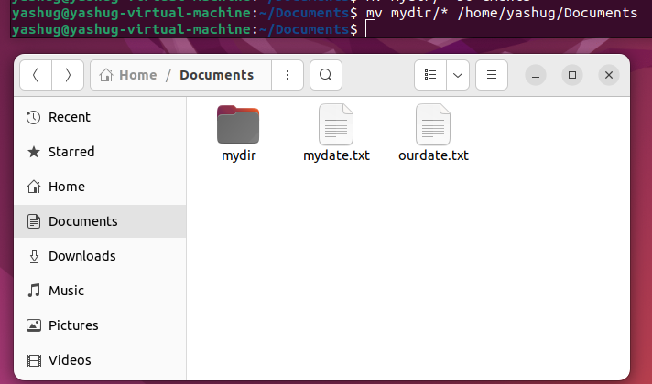

1. List all the files in your HOME directory.



1. Display the first 5 lines of *mydate*.

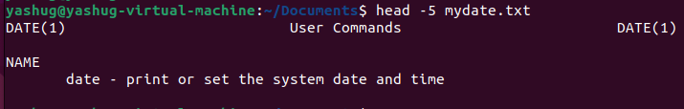

1. Display the last 8 lines of *mydate*.

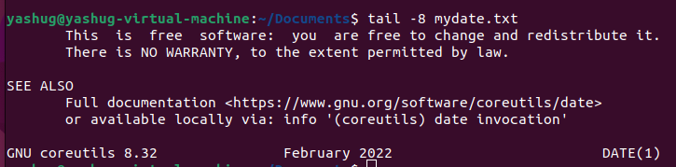

1. Remove the directory *mydir*.



1. Redirect the output of the long listing of files to a file named *list*.

